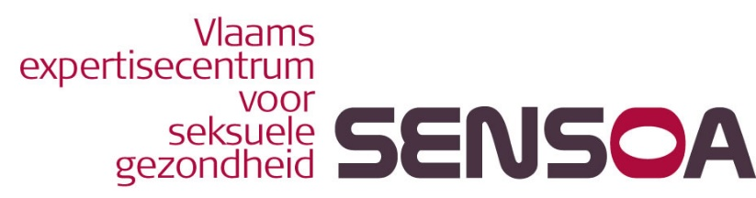

Sensoa, Flemish expertise centre for sexual health

Sensoa promotes sexual health as a centre of expertise in Flanders (Belgium) and does so with an international perspective.

Sensoa works on the basis of the World Health Organisation's definition of "sexual health". Sexual health is more than just the absence of disease and preventing the risks of unplanned pregnancy, sexual abuse, STDs or HIV. Attention should also be paid to the pleasurable and positive aspects of sexuality. This then translates itself into a constructive, respectful approach towards sexuality and sexual relationships.

For Sensoa, sexual health is inextricably linked with promoting and safeguarding sexual rights. We believe that sexual rights should be respected, safeguarded and upheld so that everyone is able to experience his or her sexuality free from coercion, discrimination and violence.

Key issues for Sensoa are the promotion of comprehensive sexuality education, the prevention of STDs and HIV, the prevention of unplanned pregnancies, the prevention of sexual abuse and the integration of people living with HIV.

Sensoa is a dynamic organisation that not only responds to change but also plans for and pre-empts future developments. Wherever possible, we work together to ensure the maximum involvement of our partners.

Evidence-based work is essential: our approach is based on (proven) facts and best practices. Sensoa is not only directed towards the general public, but also towards specific vulnerable groups.

Sensoa defends sexual rights. Everyone is entitled to the fullest possible expression of their sexuality, as long as there is consent from all parties involved and no harm is inflicted on oneself or one’s partner.

https://sensoa.be

https://www.facebook.com/sensoa

https://twitter.com/Sensoa_be

https://www.youtube.com

